Module 1. Java basics

Defining classes in a package using the package statement

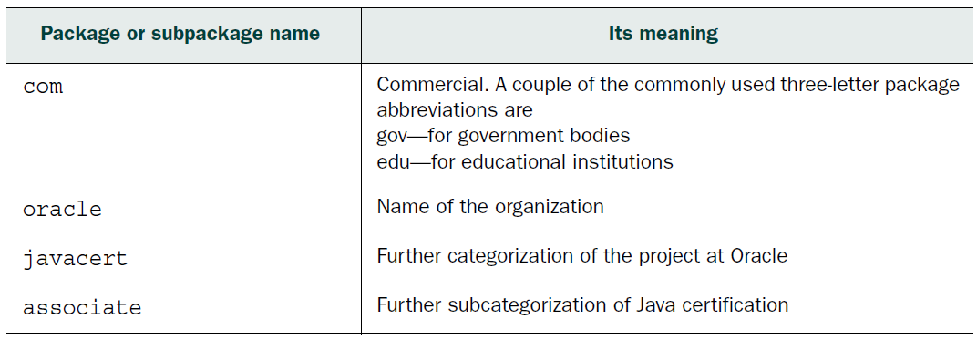

Table. Package-naming conventions used in the package name

Java access modifiers

HOW MANY ACCESS MODIFIERS ARE THERE: THREE OR FOUR?

- public (least restrictive)
- protected
- default
- private (most restrictive)

Public access modifier

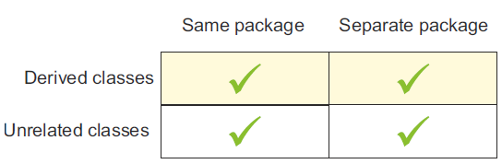

Figure. Classes that can access a public class and its members

Protected access modifier

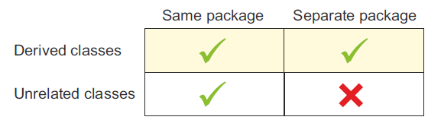

Figure. Classes that can access protected members

Default access (package access)

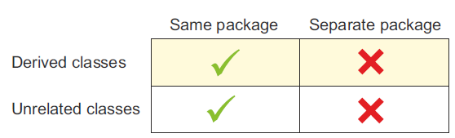

Figure. The classes that can access members with default (package) access

Private access modifier

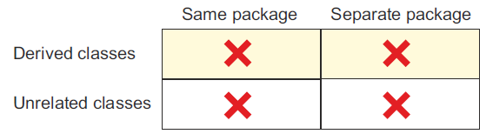

Figure. No classes can access private members of another class

Nonaccess modifiers

- abstract
- static
- final
- synchronized
- native
- strictfp
- transient
- volatile

Review notes

The structure of a Java class and source code file:

■ A class can define multiple components. All the Java components you’ve heard of can be defined within a Java class: import and package statements, variables, constructors, methods, comments, nested classes, nested interfaces, annotations, and enums.
■ If a class defines a package statement, it should be the first statement in the class definition.
■ The package statement can’t appear within a class declaration or after the class declaration.
■ If present, the package statement should appear exactly once in a class.
The import statement uses simple names of classes and interfaces from within the class.
■ The import statement can’t be used to import multiple classes or interfaces with the same name.
■ A class can include multiple import statements.
■ If a class includes a package statement, all the import statements should follow the package statement.
■ Comments are another component of a class. Comments are used to annotate Java code and can appear at multiple places within a class.
■ A comment can appear before or after a package statement, before or after the class definition, and before, within, or after a method definition.
■ Comments come in two flavors: multiline and end-of-line comments.
■ Comments can contain any special characters (including characters from the Unicode charset).
■ Multiline comments span multiple lines of code. They start with /* and end with */.
■ End-of-line comments start with // and, as the name suggests, are placed at the end of a line of code. The text between // and the end of the line is treated as a comment.
■ Class declarations and class definitions are components of a Java class.
■ A Java class may define zero or more instance variables, methods, and constructors.
■ The order of the definition of instance variables, constructors, and methods doesn’t matter in a class.
■ A class may define an instance variable before or after the definition of a
method and still use it.
■ A Java source code file (.java file) can define multiple classes and interfaces.
■ A public class can be defined only in a source code file with the same name.
■ package and import statements apply to all the classes and interfaces defined in the same source code file (.java file).

Executable Java applications:

■ An executable Java class is a class that, when handed over to the Java Virtual Machine (JVM), starts its execution at a particular point in the class. This point of execution is the main method.
■ For a class to be executable, the class should define a main method with the signature public static void main(String args[]) or public static void
main(String... args). The positions of static and public can be interchanged,
and the method parameter can use any valid name.
■ A class can define multiple methods with the name main, provided that the signature of these methods doesn’t match the signature of the main method defined in the previous point. These other methods with different signatures aren’t considered the main method.
■ The main method accepts an array of type String containing the method
parameters passed to it by the JVM.
■ The keyword java and the name of the class aren’t passed on as command parameters to the main method.

Java packages:

■ You can use packages to group together a related set of classes and interfaces.
■ By default, all classes and interfaces in separate packages and subpackages aren’t visible to each other.
■ The package and subpackage names are separated using a period.
■ All classes and interfaces in the same package are visible to each other.
■ An import statement allows the use of simple names for packaged classes and interfaces defined in other packages.
■ You can’t use the import statement to access multiple classes or interfaces with the same names from different packages.
■ You can import either a single member or all members (classes and interfaces) of a package using the import statement.
■ You can’t import classes from a subpackage by using the wildcard character, an asterisk (*), in the import statement.
■ A class from a default package can’t be used in any named packaged class, regardless of whether it’s defined within the same directory or not.
■ You can import an individual static member of a class or all its static members by using a static import statement.
■ An import statement can’t be placed before a package statement in a class. Any attempt to do so will cause the compilation of the class to fail.
■ The members of default packages are accessible only to classes or interfaces defined in the same directory on your system.

Java access modifiers:

■ The access modifiers control the accessibility of your class and its members outside the class and package.
■ Java defines four access modifiers: public, protected, default, and private.
■ The public access modifier is the least restrictive access modifier.
■ Classes and interfaces defined using the public access modifier are accessibleto related and unrelated classes outside the package in which they’re defined.
■ The members of a class defined using the protected access modifier are accessible to classes and interfaces defined in the same package and to all derived classes, even if they’re defined in separate packages.
■ The members of a class defined without using an explicit access modifier are defined with package accessibility (also called default accessibility).
■ The members with package access are accessible only to classes and interfaces defined in the same package.
■ A class defined using default access can’t be accessed outside its package.
■ The members of a class defined using a private access modifier are accessible only to the class in which they are defined. It doesn’t matter whether the class or interface in question is from another package or has extended the class. Private members are not accessible outside the class in which they’re defined.
■ The private access modifier is the most restrictive access modifier.

Nonaccess modifiers:
■ The nonaccess modifiers change the default properties of a Java class and its members.
■ An abstract class cannot be instantiated.
■ An interface is an abstract entity by default. The Java compiler automatically adds the keyword abstract to the definition of an interface (which means that adding the keyword abstract to the definition of an interface is redundant).
■ An abstract method doesn’t have a body, which means it’s implemented by the class that extends the class defining the abstract method.
■ A variable can’t be defined as an abstract variable.
■ The static modifier can be applied to inner classes, inner interfaces, variables, and methods. Inner classes and interfaces aren’t covered in this exam.
■ A method can’t be defined both as abstract and static.
■ static attributes (fields and methods) are common to all instances of a class and aren’t unique to any instance of a class.
■ static attributes exist independent of any instances of a class and may be
accessed even when no instances of the class have been created.
■ static attributes are also known as class fields or class methods because they’re said to belong to their class, not to any instance of that class.
■ A static variable or method can be accessed using the name of a reference object variable or the name of a class.
■ A static method or variable can’t access non-static variables or methods of a class. But the reverse is true: non-static variables and methods can access static variables and methods.
■ You can’t prefix the definition of a top-level class or an interface with the keyword static. A top-level class or interface is one that isn’t defined within
another class or interface.

Sample questions

Q1-1. What are the valid components of a Java source file (choose all that apply):
a package statement
b import statements
c methods
d variables
e Java compiler
f Java Runtime Environment

Q1-2. The following numbered list of Java class components is not in any particular order. Select the correct order of their occurrence in a Java class (choose all that apply):
1 comments
2 import statement
3 package statement
4 methods
5 class declaration
6 variables
a 1, 3, 2, 5, 6, 4
b 3, 1, 2, 5, 4, 6
c 3, 2, 1, 4, 5, 6
d 3, 2, 1, 5, 6, 4

Q1-3. Which of the following examples define the correct Java class structure?
a #connect java compiler;
#connect java virtual machine;
class EJavaGuru {}
b package java compiler;
import java virtual machine;
class EJavaGuru {}
c import javavirtualmachine.*;
package javacompiler;
class EJavaGuru {
void method1() {}
int count;
}
d package javacompiler;
import javavirtualmachine.*;
class EJavaGuru {
void method1() {}
int count;
}
#package javacompiler;
$import javavirtualmachine;
class EJavaGuru {
void method1() {}
int count;
}
f package javacompiler;
import javavirtualmachine;
Class EJavaGuru {
void method1() {}
int count;
}

Q1-4. Given the following contents of the Java source code file MyClass.java, select the correct options:
// contents of MyClass.java
package com.ejavaguru;
import java.util.Date;
class Student {}
class Course {}
a The imported class, java.util.Date, can be accessed only in the class Student.
b The imported class, java.util.Date, can be accessed by both the Student and Course classes.
c Both of the classes Student and Course are defined in the package com.ejavaguru.
d Only the class Student is defined in the package com.ejavaguru. The class
Course is defined in the default Java package.

Q1-5. Given the following definition of the class EJavaGuru,
class EJavaGuru {
public static void main(String[] args) {
System.out.println(args[1]+":"+ args[2]+":"+ args[3]);
}
}
what is the output of the previous class, if it is executed using the following command:
java EJavaGuru one two three four
a one:two:three
b EJavaGuru:one:two
c java:EJavaGuru:one
d two:three:four

Q1-6. Which of the following options, when inserted at //INSERT CODE HERE, will print out EJavaGuru?
public class EJavaGuru {
// INSERT CODE HERE
{
System.out.println("EJavaGuru");
}
}
a public void main (String[] args)
b public void main(String args[])
c static public void main (String[] array)
d public static void main (String args)
e static public main (String args[])

Q1-7. Select the correct options:
a You can start the execution of a Java application through the main method.
b The Java compiler calls and executes the main method.
c The Java Virtual Machine calls and executes the main method.
d A class calls and executes the main method.

Q1-8. A class Course is defined in a package com.ejavaguru. Given that the physical locationof the corresponding class file is /mycode/com/ejavaguru/Course.class and execution
takes place within the mycode directory, which of the following lines of code, when inserted at // INSERT CODE HERE, will import the Course class into the class MyCourse?
// INSERT CODE HERE
class MyCourse {
Course c;
}
a import mycode.com.ejavaguru.Course;
b import com.ejavaguru.Course;
c import mycode.com.ejavaguru;
d import com.ejavaguru;
e import mycode.com.ejavaguru*;
f import com.ejavaguru*;

Q1-9. Examine the following code:
class Course {
String courseName;
}
class EJavaGuru {
public static void main(String args[]) {
Course c = new Course();
c.courseName = "Java";
System.out.println(c.courseName);
}
}
Which of the following statements will be true if the variable courseName is defined as a private variable?
a class EJavaGuru will print Java.
b class EJavaGuru will print null.
c class EJavaGuru won’t compile.
d class EJavaGuru will throw an exception at runtime.

Q1-10. Given the following definition of the class Course,
package com.ejavaguru.courses;
class Course {
public String courseName;
}
what’s the output of the following code?
package com.ejavaguru;
import com.ejavaguru.courses.Course;
class EJavaGuru {
public static void main(String args[]) {
Course c = new Course();
c.courseName = "Java";
System.out.println(c.courseName);
}
}
a The class EJavaGuru will print Java.
b The class EJavaGuru will print null.
c The class EJavaGuru won’t compile.
d The class EJavaGuru will throw an exception at runtime.

Q1-11. Given the following code, select the correct options:
package com.ejavaguru.courses;
class Course {
public String courseName;
public void setCourseName(private String name) {
courseName = name;
}
}
a You can’t define a method argument as a private variable.
b A method argument should be defined with either public or default accessibility.
c For overridden methods, method arguments should be defined with protected accessibility.
d None of the above.

